**Assignment**

**Module: 1**

**SE – Overview of IT Industry**

1. **What is software? What is software engineering?**

**Software** is set of instructions, data or programs used to operate computers and execute specific tasks. Software is a common term used to refer to applications, scripts and programs that run on a device.

**Software engineering** is the process of analyzing user needs and designing, constructing, and testing end-user applications that will satisfy these needs through the use of software programming languages. It is the application of engineering principles to software development.

1. **Types of software**
2. Application software
3. System software
4. Driver software
5. Middleware
6. Programming software
7. **Application software**

Application software or app is a computer program designed to carry out a specific task other than one relating to the operation of the computer itself, typically to be used by end-users. Word processors, media players, and accounting software are examples.

1. **System software**

System software is a program designed to run a computer's hardware and applications and manage its resources, such as its memory, processors, and devices. It also provides a platform for running application software, and system software is typically bundled with a computer's operating system.

There are different systems software types, including Windows, Linux, MacOS X, BSD, etc. Each type of system software has its own set of unique characteristics.

1. **Driver software**

Also known as device drivers, this software is often considered a type of system software. Device drivers control the devices and peripherals connected to a computer, enabling them to perform their specific tasks.

Every device that is connected to a computer needs at least one device

driver to function. Examples include software that comes with any nonstandard hardware, including special game controllers, as well as the software that enables standard hardware, such as USB storage devices, keyboards, headphones and printers.

Example: Audio Driver, Video Driver etc.

1. **Middleware**

The term middleware describes software that mediates between application and system software or between two different kinds of application software. For example, middleware enables Microsoft Windows to talk to Excel and Word.

It is also used to send a remote work request from an application in a computer that has one kind of OS, to an application in a compute with a different OS. It also enables newer applications to work with legacy ones.

Example: database middleware, application server middleware.

1. **Programming software**

Computer programmers use programming software to write code.

Programming software and programming tools enable developers to

develop, write, test and debug other software programs.

Examples of programming software include assemblers, compilers,

debuggers and interpreters.

Examples: Turbo c, Eclipse, Sublime etc.

1. **What is SDLC? Explain each phase of SDLC**

The Software Development Life Cycle (SDLC) refers to a methodology

with clearly defined processes for creating high-quality software in

detail, the SDLC methodology focuses on the following phases of

software development:



**Phase of SDLC**

1. **Requirements gathering and analysis**

This phase involves gathering information about the software requirements from stakeholders, such as customers, end-users, and business analysts.

1. **Design**

**In this phase, the software design is created, which includes the overall architecture of the software, data structures, and interfaces. It has two steps:**

1. **High-level design (HLD): It gives the architecture of software products.**
2. **Low-level design (LLD): It describes how each and every feature in the product should work and every component.**
3. **Implementation or coding**

**The design is then implemented in code, usually in several iterations, and this phase is also called as Development.**

**Things you need to know about this phase**

1. **This is the longest phase in SDLC model.**
2. **This phase consists of Front end + Middleware + Back-end.**
3. **In front-end: Development of coding is done even SEO settings are done.**
4. **In Middleware: They connect both the front end and back end.**
5. **In the back-end: A database is created.**
6. **Testing**

**The software is thoroughly tested to ensure that it meets the requirements and works correctly.**

1. **Deployment**

**After successful testing, the software is deployed to a production environment and made available to end-users.**

1. **Maintenance**

**This phase includes ongoing support, bug fixes, and updates to the software.**

**There are different methodologies that organizations can use to implement the SDLC, such as Waterfall, Agile, Scrum, V-Model and DevOps.**

1. **What is flowchart? Create a flowchart to make addition of two numbers.**

A **flowchart** is a diagram that shows an overview of a program. Flowcharts normally use standard symbols to represent the different types of instructions. These symbols are used to construct the flowchart and show the step-by-step solution to the problem. Flowcharts are sometimes known as flow diagrams

**Addition of two numbers**

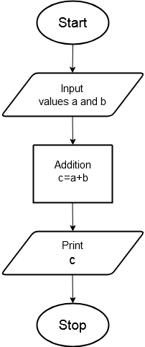

1. **What is DFD? Create a DFD diagram on Flipkart.**

A data flow diagram (DFD) is a graphical or visual representation using a standardized set of symbols and notations to describe a business's operations through data movement. They are often elements of a formal methodology such as Structured Systems Analysis and Design Method. Superficially, DFDs can resemble flow charts or Unified Modelling Language, but they are not meant to represent details of software logic.

**DFD diagram on Flipkart**

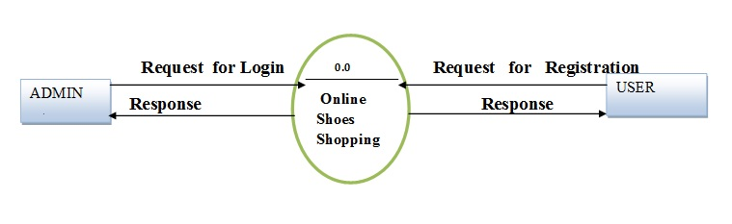

1. **What is Use case Diagram? Create a use-case on bill payment on Paytm.**

**Use-case diagrams describe the high-level functions and scope of a system. These diagrams also identify the interactions between the system and its actors. The use cases and actors in use-case diagrams describe what the system does and how the actors use it, but not how the system operates internally.**

**Create a use-case on bill payment on Paytm**

